Wine Predictive System
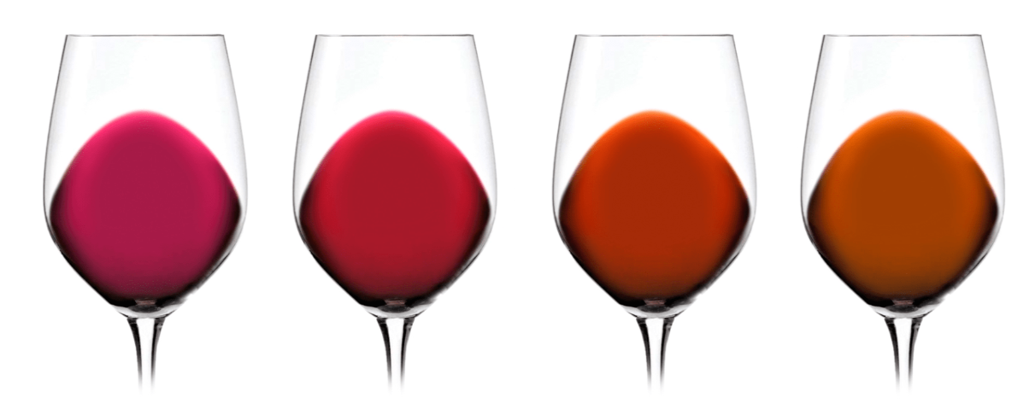



Wine Predictive System for Wine Cellars
Integration Test Plan

Version: | V01
Latest Date Version: | 16/05/2025

Any type of exploitation is prohibited, and in particular, the reproduction, distribution, public communication and/or transformation, in whole or in part, by any means, of this document without the prior express written consent of Alejandro Brome Abarzuza.

HOJA DE CONTROL

Title | Test Plan
File Name | IntegrationTestPlan.odt
Author | Alejandro Brome Abarzuza
Version | V01 | Version Date | 16/05/2025
Approved by |  | Approval Date
 |  | Nº Total Páginas | 70

CHANGE LOG
Version | Cause of change | Responsible for the change | Area | Fecha del Cambio
v01r00 | Initial | Alejandro Brome | ATOS | 16/05/2025

CONTROL DE DISTRIBUCIÓN
Name and Surname | Position | Area | Nº copies
Alejandro Brome | Developer | Development Atos | 1
Alejandro Brome | QA | Qa Departament  Atos | 1

INDEX
1 GENERAL DESCRIPTION 6
2 TEST ENVIROMENT 8
3 GENERAL CASES 9
3.1 Registration of test users 9
4 TEST CASES 10
4.1 TC001 LOGIN 10
4.2 TC002 Create user with admin ROLE 12
4.3 TC003 Delete user with admin ROLE 14
4.4 TC004 Check Wine Predictions admin ROLE 17
4.5 TC005 Delete wine prediction owned by a wine( admin ROLE ) 19
Delete wine prediction owned by a wine( admin ROLE ) 19
4.6 TC006 Check wine Prediction info (admin ROLE) 22
Check wien prediction info (admin ROLE) 22
4.7 TC007 Check Wine with no predictions (admin ROLE) 24
Check wine with no predictions yet (admin ROLE) 24
4.8 TC008 Logout (Login with both admin and customer credentials) 26
Check wine eith no predictions yet (admin ROLE) 26
4.9 TC009 Create Wine (Customer ROLE) 29
Create Wine ( Customer Role) 29
4.10 TC010 Delete Wine (Customer ROLE) 31
Delete Wine ( Customer Role) 31
4.11 TC011 Create Measure to a wine (Customer ROLE) 33
Create Measure to a wine ( Customer Role) 33
4.12 TC012 Navigate to wine Summary (Customer ROLE) 35
Navigate to wine Summary ( Customer Role) 35
4.13 TC013 Sort columns of Wine table (Customer ROLE) 37
Sort columns of Wine table (Wine list) (Customer Role) 37
4.14 TC014 Use pagination on wine list (Customer ROLE) 39
Use pagination on wine list (Wine list) (Customer Role) 39
4.15 TC015 Save prediction (Customer ROLE) 41
Save prediction (Customer Role) 41
4.16 TC016 Watching Measure calendar given a wine (Customer ROLE) 44
Watching Measure calendar given a wine (Customer Role) 44
4.17 TC017 Given a wine selected, watching predictions of its (Customer ROLE) 47
Given a wine selected, watching predictions of its (Customer Role) 47
4.18 TC018 Given a wine selected, delete a wine prediction of its. (Customer ROLE) 49
Given a wine selected, delete a wine prediction of its. (Customer Role) 49
4.19 TC019 Given a wine selected, navigate to chatIA of a wine prediction. (Customer ROLE) 52
Given a wine selected, navigate to chatIA of a wine prediction(Customer Role) 52
4.20 TC020 Watching warning icons of parameters values. (Customer ROLE) 54
Given a wine selected, navigate to chatIA of a wine prediction(Customer Role) 54
4.21 TC021 Chat IA works once a wine property is selected and pressed AskIA button (Customer ROLE) 56
Chat IA works once a wine property is selected and pressed AskIA button (Customer Role) 56
4.22 TC022 Chat Ia works once you write any message on input box and press send (Customer ROLE) 59
Chat Ia works once you write any message on input box and press send (Customer Role) 60
4.23 TC023 Given a wine selected at summary page, charts are shown adn can be filtered (Customer ROLE) 63
Given a wine selected at summary page, charts are shown adn can be filtered (Customer Role) 63
4.24 TC024 Given a wine selected, PDF can be downloaded with information of the wine selected and its predictions asociated are also shown(Customer ROLE) 65
Given a wine selected, PDF can be downloaded with information of the wine selected and its predictions asociated are also shown(Customer Role) 65
4.25 TC025 On the main page button wine prediction navigate to whiteWine-page (Customer ROLE) 68
On the main page button wine prediction navigate to whiteWine-page (Customer Role) 68

GENERAL DESCRIPTION
The ultimate goal of the system is the management of wines belonging to a winery or wine factory during the aging of the different wines belonging to the winery .
The beneficiary users will authenticate using an email and a password provided by the system administrator (in this case, Alejandro Brome).

Test Case | Code | Description
TC001 | TC001 | LOGIN (Login with both admin and customer credentials)
TC002 | TC002 | Create user with admin ROLE
TC003 | TC003 | Delete user with Admin ROLE
TC004 | TC004 | Check Wine Predictions owned by a Wine(Admin ROLE)
TC005 | TC005 | Delete wine prediction owned by a wine (Admin ROLE)
TC006 | TC006 | Check wine Prediction info (Admin ROLE)
TC007 | TC007 | Check Wine with no predictions (Admin ROLE)
TC008 | TC008 | Logout (Login with both admin and customer credentials)
TC009 | TC009 | Create Wine (Customer ROLE)
TC010 | TC010 | Delete wine (Customer ROLE)
TC011 | TC011 | Create Measure to a wine(Customer ROLE)
TC012 | TC012 | Navigate to wine Summary (Customer ROLE)
TC013 | TC013 | Sort columns of Wine table (Customer ROLE)
TC014 | TC014 | Use pagination on wine list (Customer ROLE)
TC015 | TC015 | Save prediction (Customer ROLE)
TC016 | TC016 | Watching Measure calendar given a wine (Customer ROLE)
TC017 | TC017 | Given a wine selected, watching predictions of its (Customer ROLE)
TC018 | TC018 | Given a wine selected, delete a wine prediction of its. (Customer ROLE)
TC019 | TC019 | Given a wine selected, navigate to chatIA of a wine prediction (Customer ROLE)
TC020 | TC020 | Watching warning icons of parameters values (Customer ROLE)
TC021 | TC021 | Chat IA works once a wine property is selected and pressed AskIA button (Customer ROLE)
TC022 | TC022 | Chat Ia works once you write any message on input box and press send (Customer ROLE)
TC023 | TC023 | Given a wine selected at summary page, charts are shown adn can be filtered.(Customer ROLE)
TC024 | TC024 | Given a wine selected, PDF can be downloaded with information of the wine selected and its predictions asociated are also shown (Customer ROLE)
TC025 | TC025 | On the main page button wine prediction navigate to whiteWine-page

TEST ENVIROMENT
Below is the testing environment used to verify the correct operation of the application.

Test enviroment features
Application tecnology | Java and Angular
JVM Required | Jdk1.8.0_121 or higher
Hardware/Software Requirements | Processor: At least 1 GHz.  Memory RAM: Minimum 4 GB (recommended 8 GB or plus).  Hard drive space at least 20 GB free.
Browser Version | Chrome, Firefox, Vivaldi, Opera.
Auxiliary Tools | Mysql for database
Others | N/A

GENERAL CASES

Registration of test users

Test Users | Description of registration
User registration as a Customer | To register a user with the Customer role, the following INSERT must be made in the wineprediction database:  INSERT INTO users (id, email, name, password, user_role)  VALUES(1,'usuario@example.com','username', 'yourPassword', '1');
User registration as a Admin | To register a user with the administrator role, you must request it from the application owner; administrator roles cannot be entered into the application interface.

TEST CASES

TC001 LOGIN
Description |  | Login with both admin and customer credentials
Requirements |  | A user with the Admin role and another user with the Customer role must be registered
Test Data |  | Rol Admin:  Email: admin@gmail.com  password:aurora10
Other test elements |  | N/A
Time required | Functional requirement |  | Execution sequence
10 minutes | TC001 |  | Sequential

Cycle 1
Step | Description | Window/Screen | Input data | Output | Observations
1 | We access the system, which must be installed in our environment, and we place ourselves right in the system access window | System access window.  http://localhost:4200/ | Administrator credentials:  email, password  Described in the requirements for this test case | Main System window:  Path:  http://localhost:4200/homeAdmin | 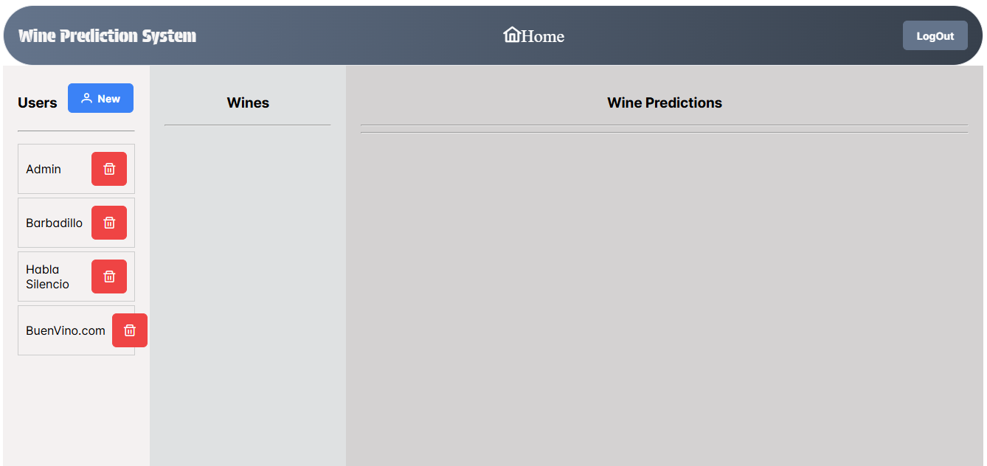
Cycle 2
Step | Description | Window/Screen | Input data | Output | Observations
1 | We access the system, which must be installed in our environment, and we place ourselves right in the system access window | System access window.  http://localhost:4200/ | Customer credentials:  email, password  Described in the point  3,1 Registration of test users | Main System window:  Path:  http://localhost:4200/homeAdmin | 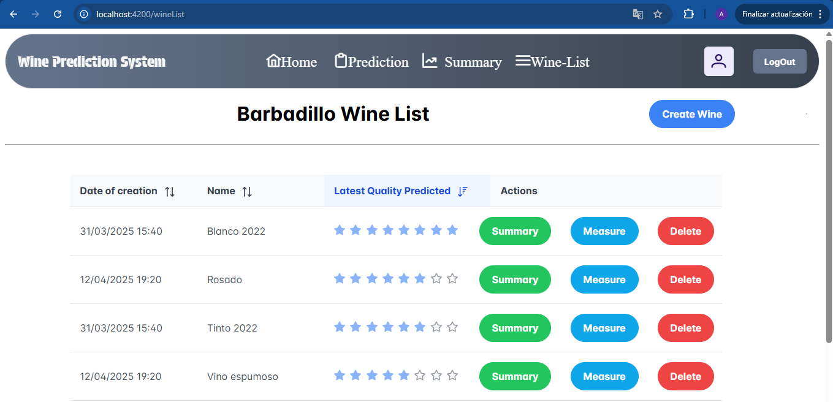

TC002 Create user with admin ROLE
Description |  | Create Customer with admin ROLE logged
Requirements |  | A user with the Admin role must be registered
Test Data |  | Rol Admin:  Email: admin@gmail.com  password:aurora10
Other test elements |  | N/A
Time required | Functional requirement |  | Execution sequence
10 minutes | TC002 |  | Sequential

Cycle 1
Step | Description | Window/Screen | Input data | Output | Observations
1 | We access the system, which must be installed in our environment, and we place ourselves right in the system access window | System access window.  http://localhost:4200/ | Administrator credentials:  email, password  Described in the requirements for this test case. | Main System window:  Path:  http://localhost:4200/homeAdmin
2 | Press the ‘New’ button next to the Users text | Main window on Admin Role  http://localhost:4200/homeAdmin | N/A | Navigate to http://localhost:4200/signup  Where a form is displayed with fields :  Email, password, password confirmation,username and the ‘Save Customer’ button | 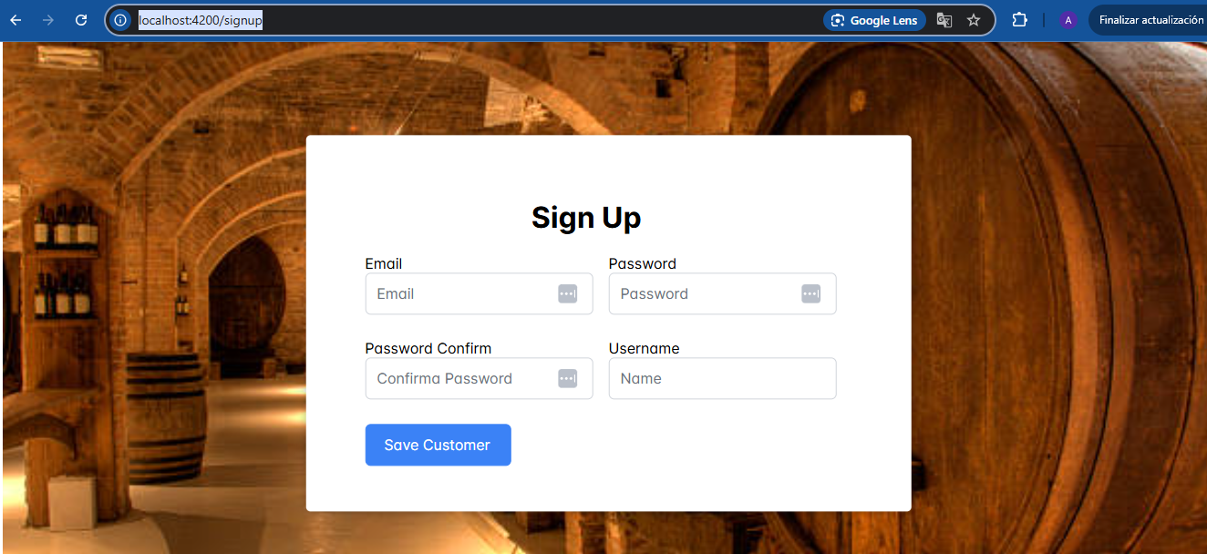
3 | Enter the fields in the form | http://localhost:4200/signup | Email:exampleTest@gmail.com  Password:mysecretPassword  Password confirm:mysecretPassword  username:testname | System will navigate back to http://localhost:4200/homeAdmin | In the case that Field ‘Password Confirm’ des not match with field ‘Password’ input box will show at red color and system will not save the user.  Same will happen if the ‘email field’ does not match with valid email.

TC003 Delete user with admin ROLE
Description |  | Delete User with admin ROLE
Requirements |  | A user with the Admin role must be registered
Test Data |  | Rol Admin:  Email: admin@gmail.com  password:aurora10
Other test elements |  | N/A
Time required | Functional requirement |  | Execution sequence
10 minutes | TC003 |  | Sequential

Cycle 1
Step | Description | Window/Screen | Input data | Output | Observations
1 | We access the system, which must be installed in our environment, and we place ourselves right in the system access window | System access window.  http://localhost:4200/ | Administrator credentials:  email, password  Described in the requirements for this test case. | Main System window:  Path:  http://localhost:4200/homeAdmin
2 |   Press the ‘trash’  button next to the User’s names | Main window on Admin Role  http://localhost:4200/homeAdmin | N/A | Confirmation Dialog will be shown with ‘Yes’ and ‘No’ | 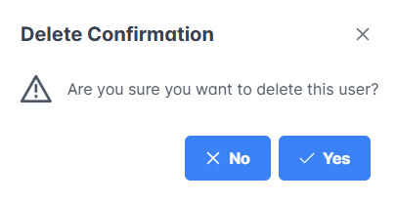
3 | Press ‘Yes’ button | Main window on Admin Role | N/A | User will not appear onthe users list on the left side of the site | In the case that we press the ‘no’ button of the dialog, system will go back to the main page and the user will be on the users list yet.

TC004 Check Wine Predictions admin ROLE
Description |  | Check Wine Predictions with admin ROLE
Requirements |  | A user with unless one associate wine and unless one prediction associate to that wine  In case theres is not a user with wine associated execute TC009 (Customer Rol)  In case theres is not a wine with wine Prediction associated execute TC015 (Customer Rol)
Test Data |  | Rol Admin:  Email: admin@gmail.com  password:aurora10
Other test elements |  | N/A
Time required | Functional requirement |  | Execution sequence
10 minutes | TC004 |  | Not Sequential

Cycle 1
Step | Description | Window/Screen | Input data | Output | Observations
1 | We access the system, which must be installed in our environment, and we place ourselves right in the system access window | System access window.  http://localhost:4200/ | Administrator credentials:  email, password  Described in the requirements for this test case. | Main System window:  Path:  http://localhost:4200/homeAdmin
2 | Press the ‘User name’ user  on the users list on the left side of the site | Main window on Admin Role  http://localhost:4200/homeAdmin | N/A | Wine List associated to the selected user will apear on Wines column | 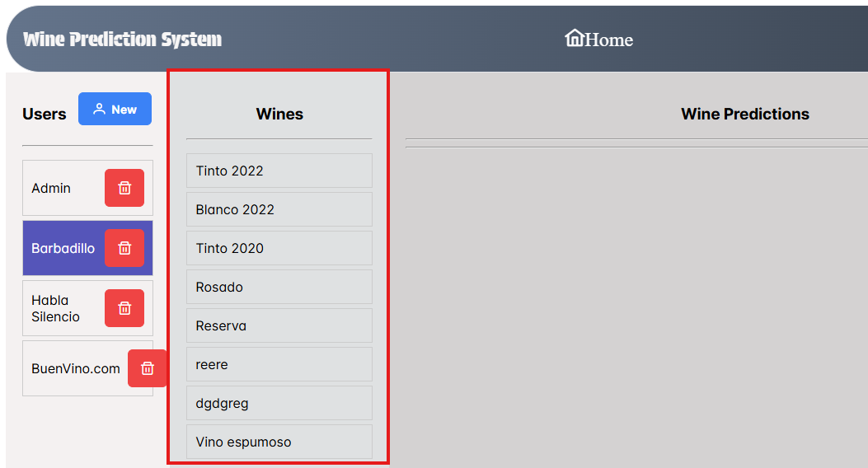
3 | Press one of the wine with prediction associated | Main window on Admin Role | N/A | List of predictions belonged to the wine selected | 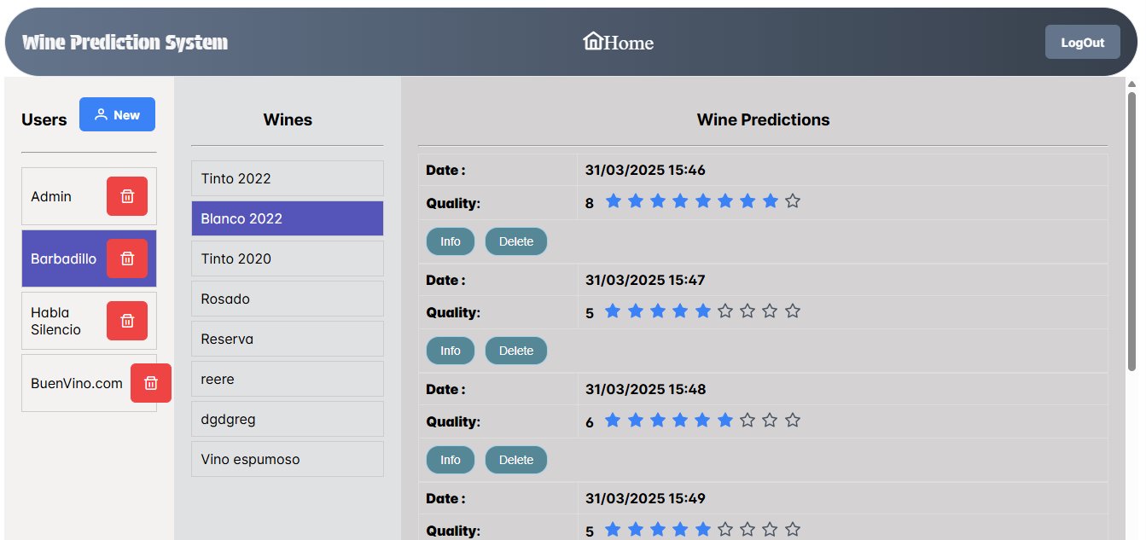  ‘No predictions so far’ will appear if the wine selected has not predictions yet

TC005 Delete wine prediction owned by a wine( admin ROLE )
Description |  | Delete wine prediction owned by a wine( admin ROLE )
Requirements |  | A user with unless one associate wine and unless one prediction associate to that wine  In case theres is not a user with wine associated execute TC009 (Customer Rol)  In case theres is not a wine with wine Prediction associated execute TC015 (Customer Rol)
Test Data |  | Rol Admin:  Email: admin@gmail.com  password:aurora10
Other test elements |  | N/A
Time required | Functional requirement |  | Execution sequence
10 minutes | TC005 |  | Not Sequential

Cycle 1
Step | Description | Window/Screen | Input data | Output | Observations
1 | We access the system, which must be installed in our environment, and we place ourselves right in the system access window | System access window.  http://localhost:4200/ | Administrator credentials:  email, password  Described in the requirements for this test case. | Main System window:  Path:  http://localhost:4200/homeAdmin
2 | Press the ‘User name’ user  on the users list on the left side of the site  ‘Barbadillo’ | Main window on Admin Role  http://localhost:4200/homeAdmin | N/A | Wine List associated to the selected user will apear on Wines column
3 | Press one of the wine with prediction associated | Main window on Admin Role | N/A | List of predictions belonged to the wine selected | ‘No predictions so far’ will appear if the wine selected has not predictions yet
4 | Press the ‘Delete’ button of any prediction of the list | Main window on Admin Role | N/A | Dialog will come up with 2 options both ‘Yes’ and ‘No’
5 | Press ‘Yes’ in dialog Panel | Main window on Admin Role | N/A | Prediction selected and deleted will not appear on the table anymore | In case you press ‘No’ at dialog Panel, the selected prediction will stil appear on the table of predictions.

TC006 Check wine Prediction info (admin ROLE)
Description |  | Check wien prediction info (admin ROLE)
Requirements |  | A user with unless one associate wine and unless one prediction associate to that wine  In case theres is not a user with wine associated execute TC009 (Customer Rol)  In case theres is not a wine with wine Prediction associated execute TC015 (Customer Rol)
Test Data |  | Rol Admin:  Email: admin@gmail.com  password:aurora10
Other test elements |  | N/A
Time required | Functional requirement |  | Execution sequence
10 minutes | TC006 |  | Not Sequential

Cycle 1
Step | Description | Window/Screen | Input data | Output | Observations
1 | We access the system, which must be installed in our environment, and we place ourselves right in the system access window | System access window.  http://localhost:4200/ | Administrator credentials:  email, password  Described in the requirements for this test case. | Main System window:  Path:  http://localhost:4200/homeAdmin
2 | Press the ‘User name’ user  on the users list on the left side of the site  ‘Barbadillo’ | Main window on Admin Role  http://localhost:4200/homeAdmin | N/A | Wine List associated to the selected user will apear on Wines column
3 | Press one of the wine with prediction associated | Main window on Admin Role | N/A | List of predictions belonged to the wine selected | ‘No predictions so far’ will appear if the wine selected has not predictions yet
4 | Press the ‘Info’ button of any prediction of the list | Main window on Admin Role | N/A | A dialog Panel will appear with all the prediction information, incluiding properties, values, and date | 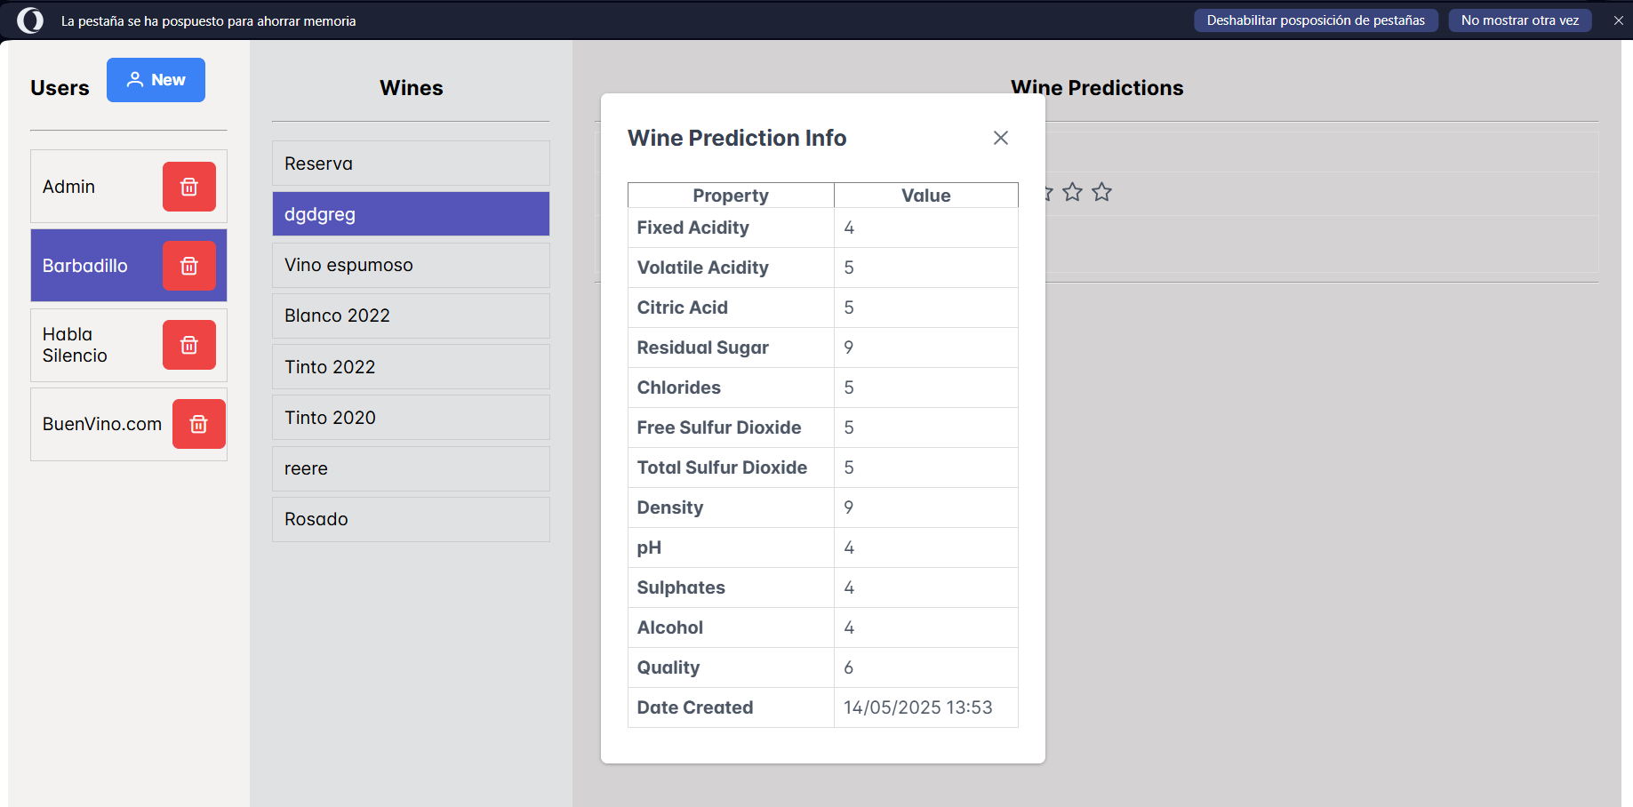

TC007 Check Wine with no predictions (admin ROLE)
Description |  | Check wine with no predictions yet (admin ROLE)
Requirements |  | A user with unless one associate wine.
Test Data |  | Rol Admin:  Email: admin@gmail.com  password:aurora10
Other test elements |  | N/A
Time required | Functional requirement |  | Execution sequence
10 minutes | TC008 |  | Not Sequential

Cycle 1
Step | Description | Window/Screen | Input data | Output | Observations
1 | We access the system, which must be installed in our environment, and we place ourselves right in the system access window | System access window.  http://localhost:4200/ | Administrator credentials:  email, password  Described in the requirements for this test case. | Main System window:  Path:  http://localhost:4200/homeAdmin
2 | Press the user  on the users list on the left side of the site | Main window on Admin Role  http://localhost:4200/homeAdmin | N/A
3 | Press one of the wine without prediction assocciated | Main window on Admin Role | N/A | List of predictions belonged to the wine selected | ‘No predictions so far’  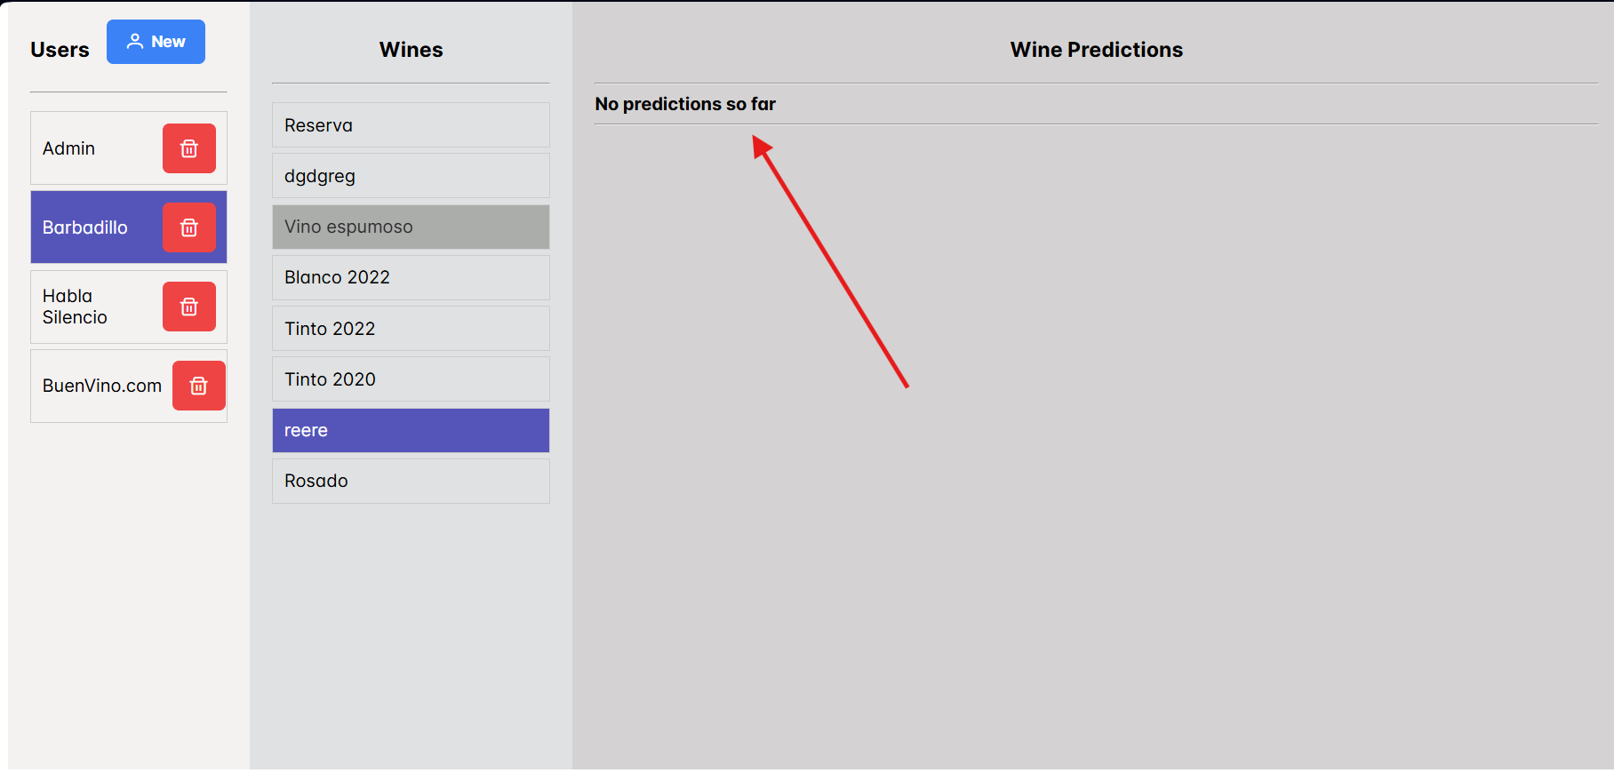

TC008 Logout (Login with both admin and customer credentials)
Description |  | Check wine eith no predictions yet (admin ROLE)
Requirements |  | A user with unless one associate wine.  In case there is no a wine created, execute TC009
Test Data |  | Rol Admin:  Email: admin@gmail.com  password:aurora10
Other test elements |  | N/A
Time required | Functional requirement |  | Execution sequence
10 minutes | TC008 |  | Not Sequential

Cycle 1
Step | Description | Window/Screen | Input data | Output | Observations
1 | We access the system, which must be installed in our environment, and we place ourselves right in the system access window | System access window.  http://localhost:4200/ | Administrator credentials:  email, password  Described in the requirements for this test case. | Main System window:  Path:  http://localhost:4200/homeAdmin
2 | Press the ‘Logout’ button on the up-right side of the screen | Main window on Admin Role  http://localhost:4200/homeAdmin | N/A | System will navigate to Login Page | 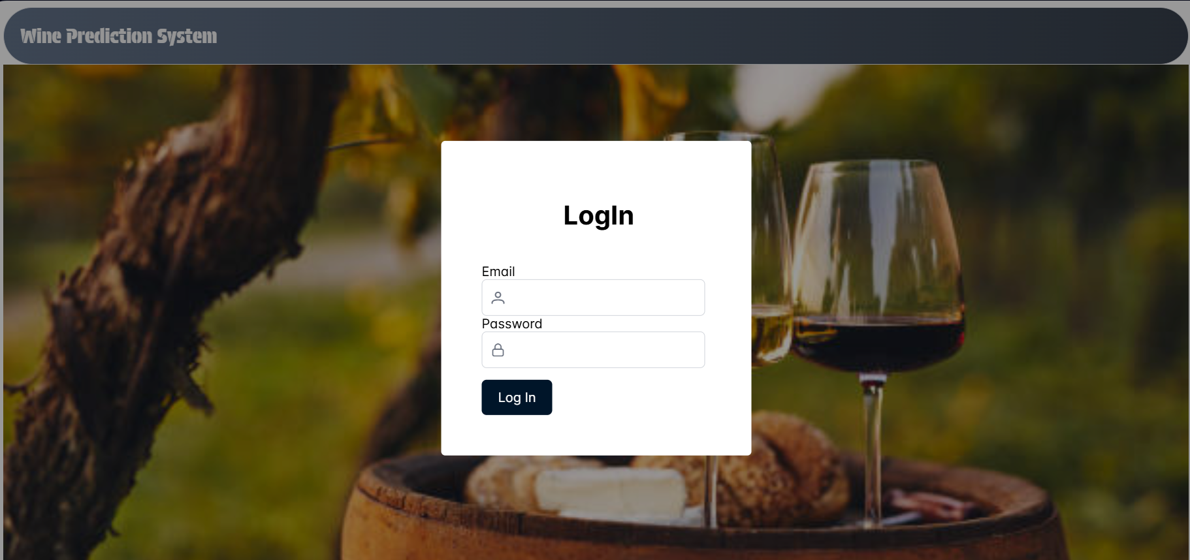
3 | Log in the system with Customer credentials |  | Customer credentials | Main System window:  Path:  http://localhost:4200/wineList | 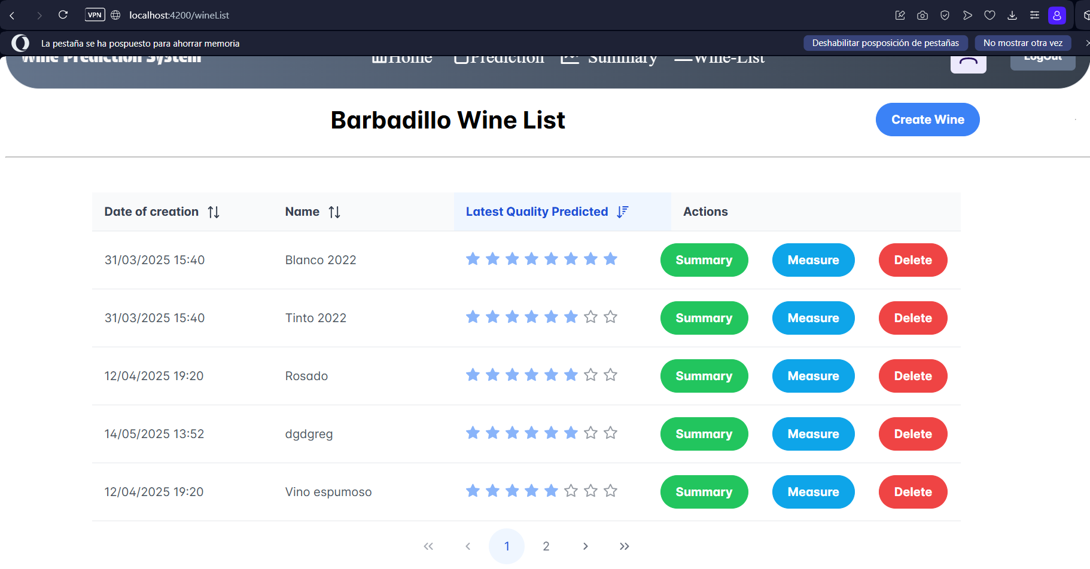
4 | Press the ‘Logout’ button on the up-right side of the screen | Main window on Admin Role  http://localhost:4200/wineList | N/A | System will navigate to Login Page

TC009 Create Wine (Customer ROLE)
Description |  | Create Wine ( Customer Role)
Requirements |  | A user with unless one associate wine.  In case there is no a wine created, execute TC009
Test Data |  | If we do not have customer credentials, Admin will create a new one ( execute TC002 )
Other test elements |  | N/A
Time required | Functional requirement |  | Execution sequence
10 minutes | TC009 |  | Sequential

Cycle 1
Step | Description | Window/Screen | Input data | Output | Observations
1 | We access the system, which must be installed in our environment, and we place ourselves right in the system access window | System access window.  http://localhost:4200/wineList | Customer credentials:  email, password  As we introduce in test case TC002 | Main System window:  Path:  http://localhost:4200/wineList | 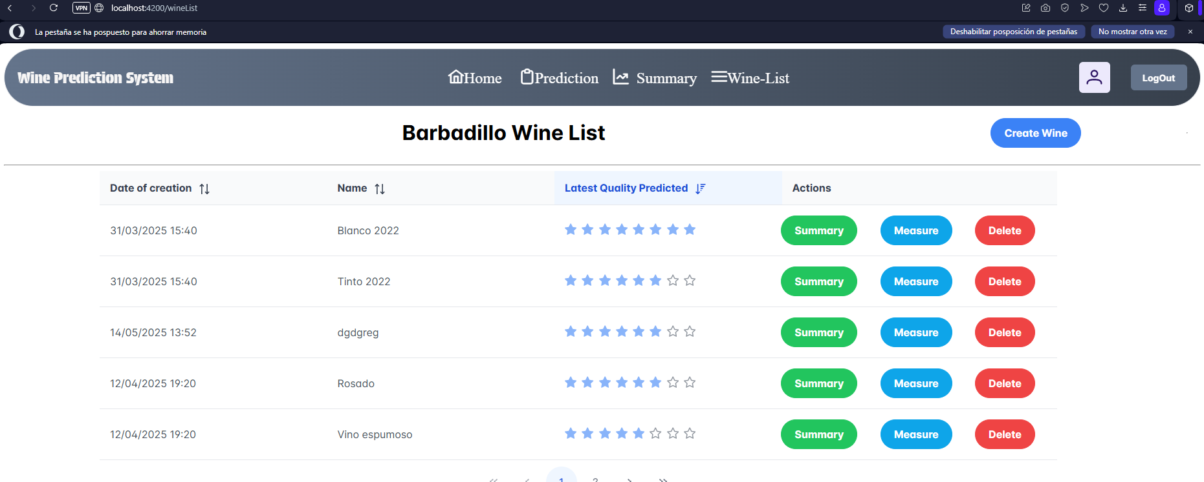
2 | Press the ‘Create Wine’ button on the up-right side of the screen | Main window on Admin Role  http://localhost:4200/wineList  A dialog Panel will come up as we press the ‘Create wine’ button with fields:  Wine name:more than 3 characters  Date:will be disable and will show today date | A dialog Panel will come up as we press the ‘Create wine’ button with fields:  Wine name:more than 3 characters  Date:will be disable and will be shown.  Press `Save` and the system will go back to wine List and a success toast will show up on the up-right side of the screen.  If name does not have 3 characters length, system will not save the wine.  If we press `Cancel button` inside the panel, system will go back to wine list panel. | System will navigate to wineList Page | The Dialog panel will look like this:  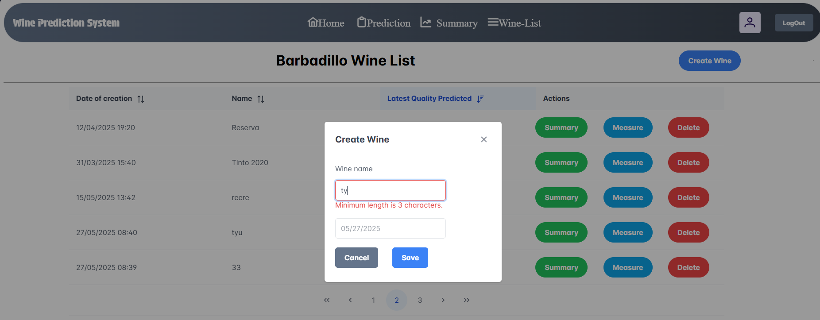

TC010 Delete Wine (Customer ROLE)
Description |  | Delete Wine ( Customer Role)
Requirements |  | A user with unless one associate wine.  In case there is no a wine created, execute TC009
Test Data |  | If we do not have customer credentials, Admin will create a new one ( execute TC002 )
Other test elements |  | N/A
Time required | Functional requirement |  | Execution sequence
10 minutes | TC010 |  | Sequential

Cycle 1

Step | Description | Window/Screen | Input data | Output | Observations
1 | We access the system, which must be installed in our environment, and we place ourselves right in the system access window | System access window.  http://localhost:4200/wineList | Customer credentials:  email, password  As we introduce in test case TC002 | Main System window:  Path:  http://localhost:4200/wineList
2 | We press the ‘Delete button’ belonged of the wine that we wish to delete. | A confirm dialog panel will show with text ‘¿Are you sure to delete this wine? ’ |  | If we press ‘no’, system will go back to wine list and the wine will not be deleted.  If we press ‘Yes’ system will delete the wine and show the wine list with the wine deleted not included in it.

TC011 Create Measure to a wine (Customer ROLE)
Description |  | Create Measure to a wine ( Customer Role)
Requirements |  | A user with unless one associate wine.  In case there is not a wine created, execute TC009
Test Data |  | If we do not have customer credentials, Admin will create a new one ( execute TC002 )
Other test elements |  | N/A
Time required | Functional requirement |  | Execution sequence
10 minutes | TC011 |  | Sequential

Cycle 1

Step | Description | Window/Screen | Input data | Output | Observations
1 | We access the system, which must be installed in our environment, and we place ourselves right in the system access window | System access window.  http://localhost:4200/wineList | Customer credentials:  email, password  As we introduce in test case TC002 | Main System window:  Path:  http://localhost:4200/wineList
2 | We press the ‘Create measure button’ belonged of the wine that we wish to create the measure to.. | A confirm dialog panel will show with fields:  Description and date. | Description must have minimum 3 characters both numbers abd letters, otherwise thu user will not be able to save the measure due to disble ‘Save’ button | If we press ‘Cancel’, system will go back to wine list and the wine will not be deleted.  If we press ‘Yes’ system will delete the wine and show the wine list with the wine deleted not included in it. | 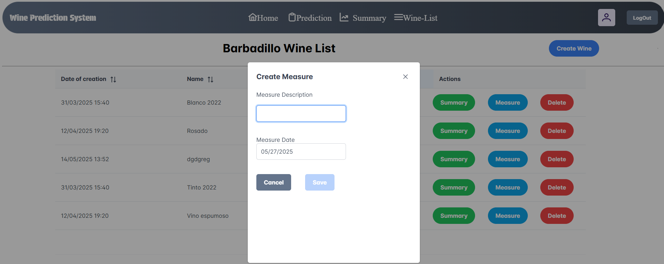

TC012 Navigate to wine Summary (Customer ROLE)
Description |  | Navigate to wine Summary ( Customer Role)
Requirements |  | A user with unless one associate wine.  In case there is not a wine created, execute TC009
Test Data |  | If we do not have customer credentials, Admin will create a new one ( execute TC002 )
Other test elements |  | N/A
Time required | Functional requirement |  | Execution sequence
10 minutes | TC012 |  | Sequential

Cycle 1

Step | Description | Window/Screen | Input data | Output | Observations
1 | We access the system, which must be installed in our environment, and we place ourselves right in the system access window | System access window.  http://localhost:4200/wineList | Customer credentials:  email, password  As we introduce in test case TC002 | Main System window:  Path:  http://localhost:4200/wineList
2 | Navigate to summary with a wine selected | Wine List Panel | We press ‘Summary button’  at any row on the wine list.  System will navigate to http://localhost:4200/summaryWhite/2 where we will find the wine already selected and see all predictions belonged to this wien | Table with all predictions belonged to the wine selected | 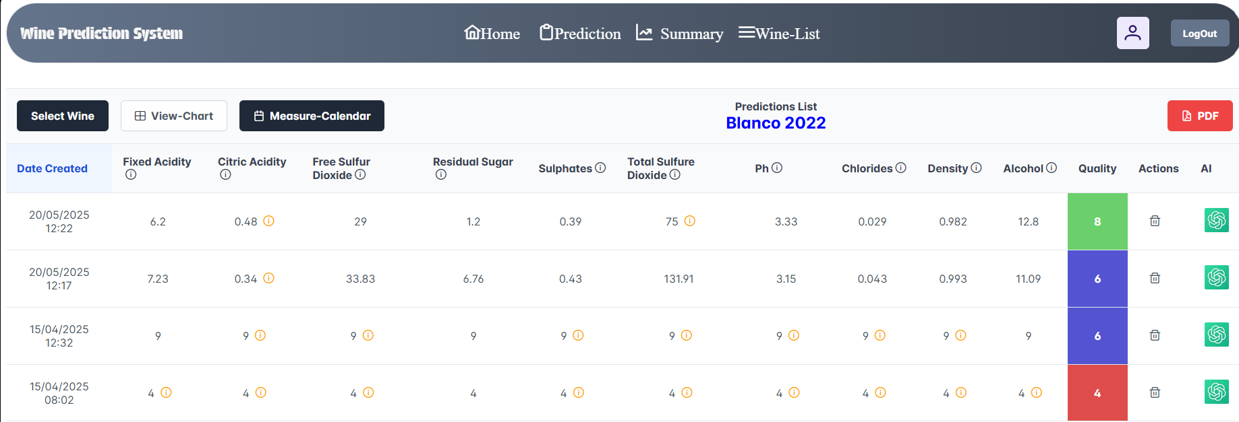

TC013 Sort columns of Wine table (Customer ROLE)
Description |  | Sort columns of Wine table (Wine list) (Customer Role)
Requirements |  | A user with unless one associate wine.  In case there is not a wine created, execute TC009
Test Data |  | If we do not have customer credentials, Admin will create a new one ( execute TC002 )
Other test elements |  | N/A
Time required | Functional requirement |  | Execution sequence
10 minutes | TC013 |  | Sequential

Cycle 1

Step | Description | Window/Screen | Input data | Output | Observations
1 | We access the system, which must be installed in our environment, and we place ourselves right in the system access window | System access window.  http://localhost:4200/wineList | Customer credentials:  email, password  As we introduce in test case TC002 | Main System window:  Path:  http://localhost:4200/wineList
2 | Sort columns | http://localhost:4200/wineList | We press ‘Arrows’ aside of every name of columns, | Table with all wines are sorted by selected columns

TC014 Use pagination on wine list (Customer ROLE)
Description |  | Use pagination on wine list (Wine list) (Customer Role)
Requirements |  | A user with unless one associate wine.  In case there is not a wine created, execute TC009
Test Data |  | If we do not have customer credentials, Admin will create a new one ( execute TC002 )
Other test elements |  | N/A
Time required | Functional requirement |  | Execution sequence
10 minutes | TC014 |  | Sequential

Cycle 1

Step | Description | Window/Screen | Input data | Output | Observations
1 | We access the system, which must be installed in our environment, and we place ourselves right in the system access window | System access window.  http://localhost:4200/wineList | Customer credentials:  email, password  As we introduce in test case TC002 | Main System window:  Path:  http://localhost:4200/wineList
2 | Use pagination buttons | http://localhost:4200/wineList | We press ‘<’ and ‘>’ to navigate trough wine list.  Every page should not have more than 4 wines | Table with all wines change as we press the slide buttons

TC015 Save prediction (Customer ROLE)
Description |  | Save prediction (Customer Role)
Requirements |  | A user with unless one associate wine.  In case there is not a wine created, execute TC009
Test Data |  | If we do not have customer credentials, Admin will create a new one ( execute TC002 )
Other test elements |  | N/A
Time required | Functional requirement |  | Execution sequence
10 minutes | TC015 |  | Sequential

Cycle 1

Step | Description | Window/Screen | Input data | Output | Observations
1 | We access the system, which must be installed in our environment, and we place ourselves right in the system access window | System access window.  http://localhost:4200/wineList | Customer credentials:  email, password  As we introduce in test case TC002 | Main System window:  Path:  http://localhost:4200/wineList
2 | Navigate to Prediction form | http://localhost:4200/whiteWine-page | We press summary button on nav-bar | Form with all parametres of a wine will appear on screen | 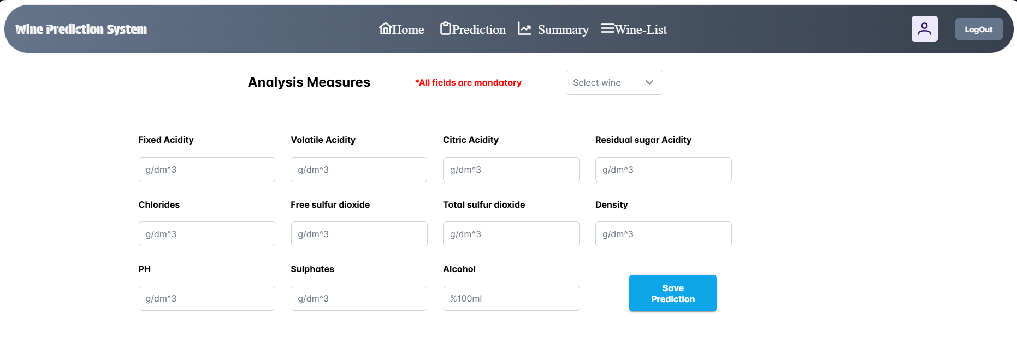
3 | Introduce values of measurements | http://localhost:4200/whiteWine-page | Select a wine on the ‘Select wine’ button on the top of the page.  Fill out all fields.  Select wine is mandatory, if we do not select a wine a danger message will be show like ‘Selet wine is mandatory’.  Fields to be filled out soul have a maximun length of 5 numbers and to be filled out ONLY with numbers.  Press ‘Save prediction’ button. | System will navigate to http://localhost:4200/summaryWhite/7 where ‘7’ will be the id of the wine.  Same wine that will selected on previous page will be shown and its predictions will appear on the table. | 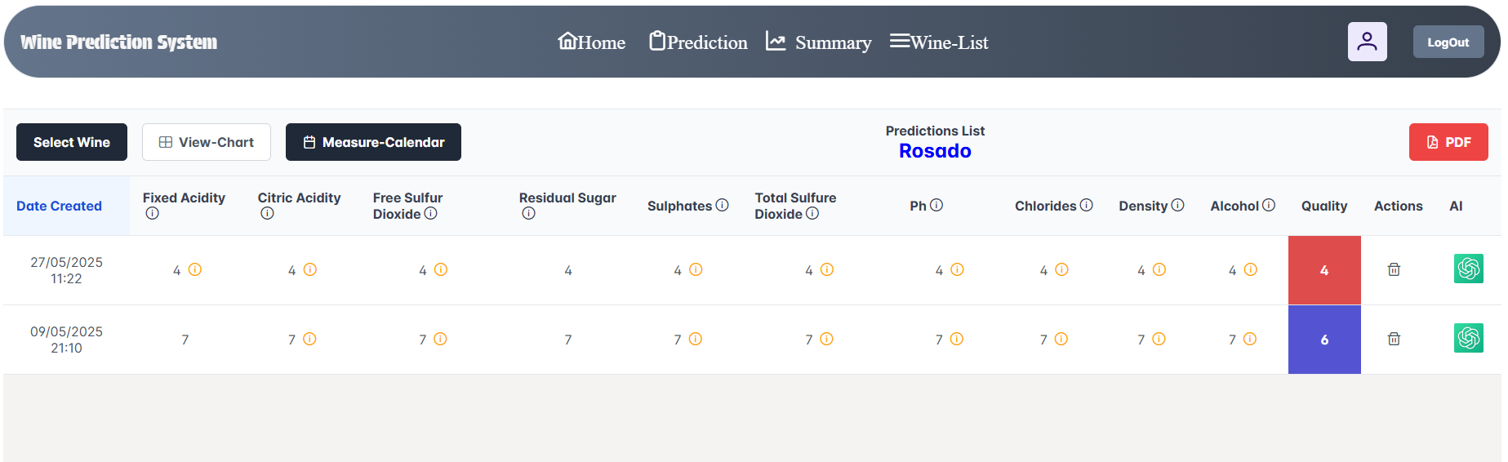

TC016 Watching Measure calendar given a wine (Customer ROLE)
Description |  | Watching Measure calendar given a wine (Customer Role)
Requirements |  | A user with unless one associate wine.  In case there is not a wine created, execute TC009
Test Data |  | If we do not have customer credentials, Admin will create a new one ( execute TC002 )
Other test elements |  | N/A
Time required | Functional requirement |  | Execution sequence
10 minutes | TC016 |  | Sequential

Cycle 1

Step | Description | Window/Screen | Input data | Output | Observations
1 | We access the system, which must be installed in our environment, and we place ourselves right in the system access window | System access window.  http://localhost:4200/wineList | Customer credentials:  email, password  As we introduce in test case TC002 | Main System window:  Path:  http://localhost:4200/wineList
2 | Go to summary white/idWine | http://localhost:4200/wineList | We press summary button on any row of the wine list(write down name of the wine) | We will see the http://localhost:4200/summaryWhite/2 with the table of predictions wihch belong to the wine selected on the previous page. | 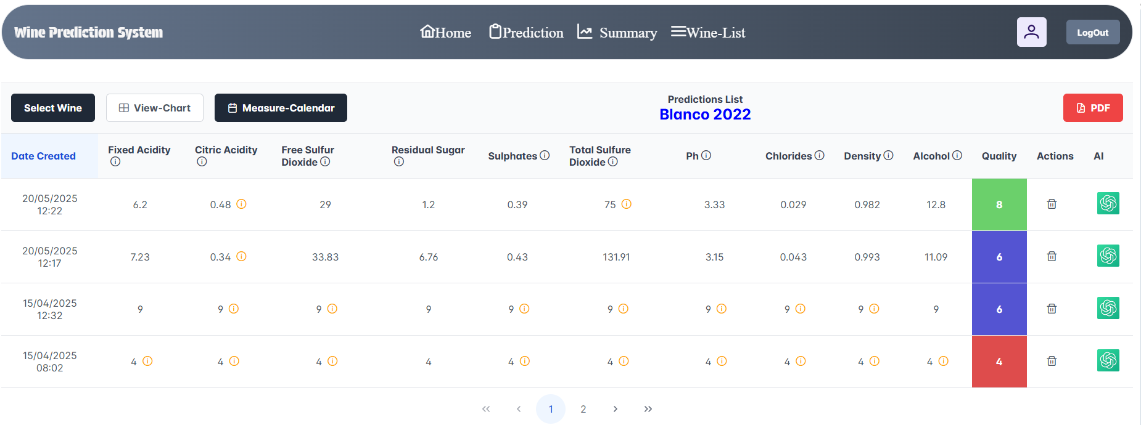
3 | View measures calendar | http://localhost:4200/whiteWine-page | Select the Measure-calendar button. | Calendar will be shown with measurements on the date that they were created. | 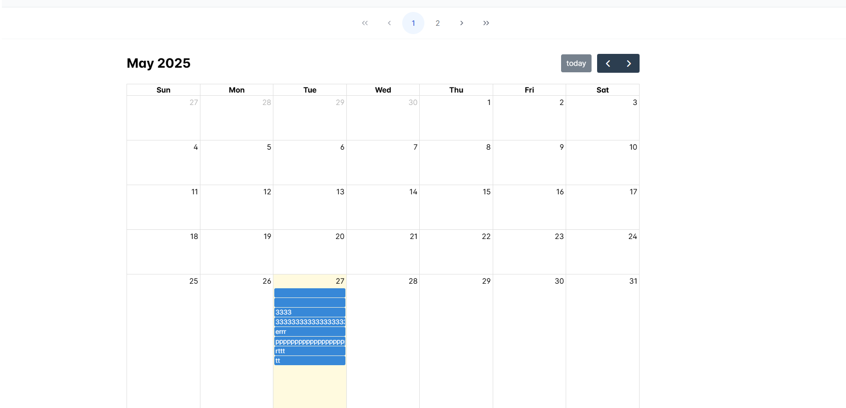
4 | View measures info | http://localhost:4200/whiteWine-page | Click on any date with various measurements. | A Dialog Panel will be shown with all measurements information belonged to the date clicked on calendar.  If we click on an empty date, dialog also will be shown but will be empty. | 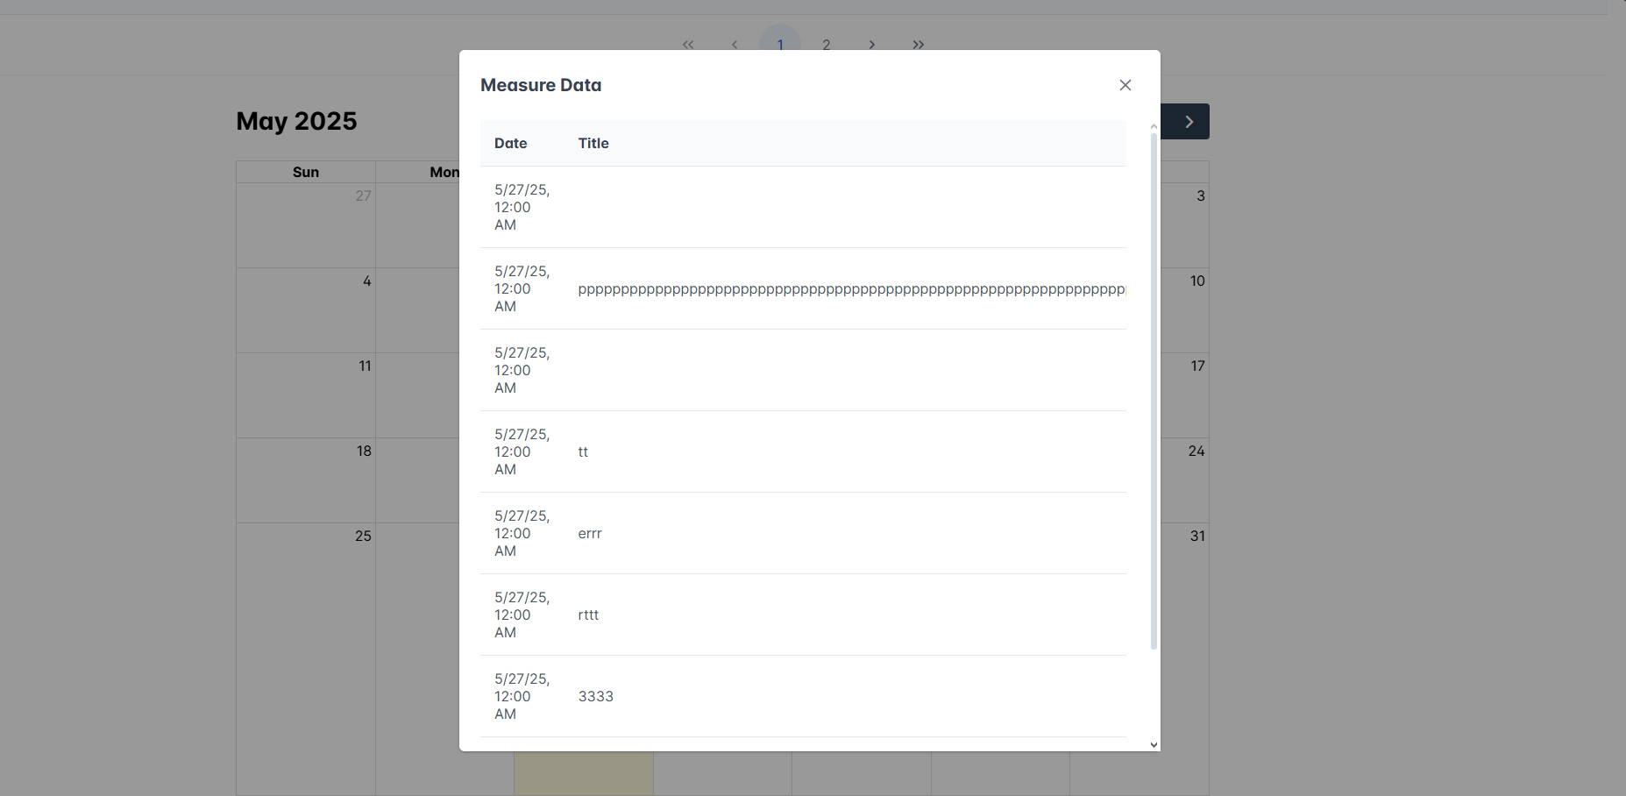

TC017 Given a wine selected, watching predictions of its (Customer ROLE)
Description |  | Given a wine selected, watching predictions of its (Customer Role)
Requirements |  | A user with unless one associate wine.  In case there is not a wine created, execute TC009
Test Data |  | If we do not have customer credentials, Admin will create a new one ( execute TC002 )
Other test elements |  | N/A
Time required | Functional requirement |  | Execution sequence
10 minutes | TC017 |  | Sequential

Cycle 1

Step | Description | Window/Screen | Input data | Output | Observations
1 | We access the system, which must be installed in our environment, and we place ourselves right in the system access window | System access window.  http://localhost:4200/wineList | Customer credentials:  email, password  As we introduce in test case TC002 | Main System window:  Path:  http://localhost:4200/wineList
2 | Go to summary white/idWine | http://localhost:4200/wineList | We press summary button on nav-bar | We will see the http://localhost:4200/summaryWhite/0 with the table of predictions empty
3 | Select wine | http://localhost:4200/whiteWine-page | Press the select wine and select a wine from the list.  If there is not a created wine we must execute TC009. | Predictions of this wine will be shown on the table.  If the wine has not predictions we must execute TC015. | 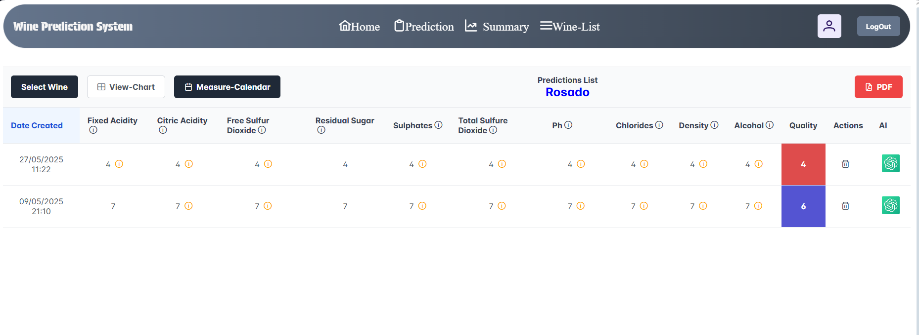

TC018 Given a wine selected, delete a wine prediction of its. (Customer ROLE)
Description |  | Given a wine selected, delete a wine prediction of its. (Customer Role)
Requirements |  | A user with unless one associate wine.  In case there is not a wine created, execute TC009
Test Data |  | If we do not have customer credentials, Admin will create a new one ( execute TC002 )
Other test elements |  | N/A
Time required | Functional requirement |  | Execution sequence
10 minutes | TC018 |  | Sequential

Cycle 1

Step | Description | Window/Screen | Input data | Output | Observations
1 | We access the system, which must be installed in our environment, and we place ourselves right in the system access window | System access window.  http://localhost:4200/wineList | Customer credentials:  email, password  As we introduce in test case TC002 | Main System window:  Path:  http://localhost:4200/wineList
2 | Go to summary white/idWine | http://localhost:4200/wineList | We press summary button on nav-bar | We will see the http://localhost:4200/summaryWhite/0 with the table of predictions empty
3 | Select wine | http://localhost:4200/whiteWine-page | Press the select wine and select a wine from the list.  If there is not a created wine we must execute TC009. | Predictions of this wine will be shown on the table.  If the wine has not predictions we must execute TC015.
4 | Delete prediction | http://localhost:4200/whiteWine-page | 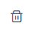  Click on delete button.  Confirmation dialog will be shown.  Press ‘yes’ and prediction will be deleted form the table automatically | Table will be shown without predictions that we just deleted

TC019 Given a wine selected, navigate to chatIA of a wine prediction. (Customer ROLE)
Description |  | Given a wine selected, navigate to chatIA of a wine prediction(Customer Role)
Requirements |  | A user with unless one associate wine.  In case there is not a wine created, execute TC009
Test Data |  | If we do not have customer credentials, Admin will create a new one ( execute TC002 )
Other test elements |  | N/A
Time required | Functional requirement |  | Execution sequence
10 minutes | TC019 |  | Sequential
Cycle 1

Step | Description | Window/Screen | Input data | Output | Observations
1 | We access the system, which must be installed in our environment, and we place ourselves right in the system access window | System access window.  http://localhost:4200/wineList | Customer credentials:  email, password  As we introduce in test case TC002 | Main System window:  Path:  http://localhost:4200/wineList
2 | Go to summary white/idWine | http://localhost:4200/wineList | We press summary button on nav-bar | We will see the http://localhost:4200/summaryWhite/0 with the table of predictions empty
3 | Select wine | http://localhost:4200/whiteWine-page | Press the select wine and select a wine from the list.  If there is not a created wine we must execute TC009. | Predictions of this wine will be shown on the table.  If the wine has not predictions we must execute TC015.
4 | Delete prediction | http://localhost:4200/whiteWine-page |   Click on AI button. | System will navigate to http://localhost:4200/chat/31 where 31 is winePredictionId.  Screen will look like pic of Observations of this row | 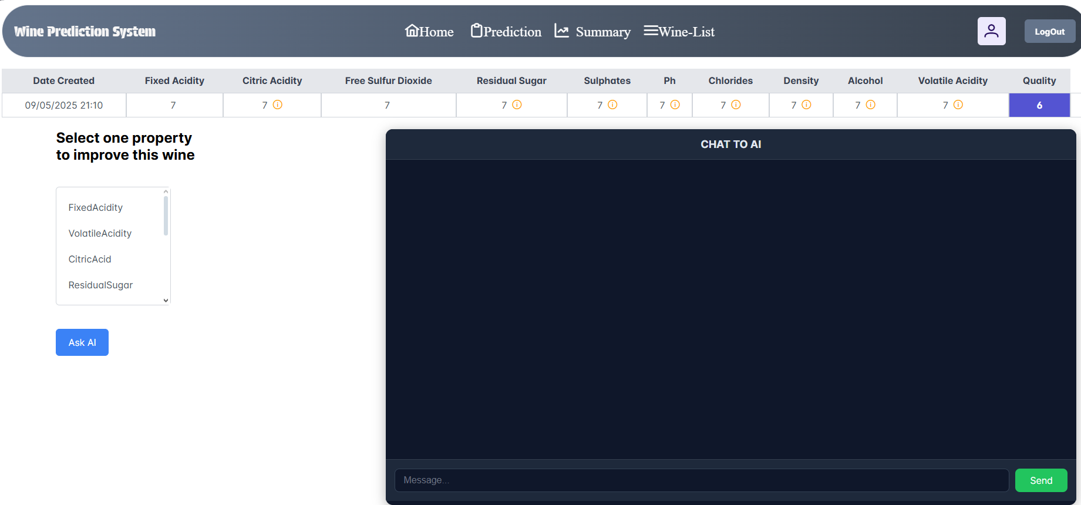

TC020 Watching warning icons of parameters values. (Customer ROLE)
Description |  | Given a wine selected, navigate to chatIA of a wine prediction(Customer Role)
Requirements |  | A user with unless one associate wine.  In case there is not a wine created, execute TC009
Test Data |  | If we do not have customer credentials, Admin will create a new one ( execute TC002 )
Other test elements |  | N/A
Time required | Functional requirement |  | Execution sequence
10 minutes | TC021 |  | Sequential
Cycle 1

Step | Description | Window/Screen | Input data | Output | Observations
1 | We access the system, which must be installed in our environment, and we place ourselves right in the system access window | System access window.  http://localhost:4200/wineList | Customer credentials:  email, password  As we introduce in test case TC002 | Main System window:  Path:  http://localhost:4200/wineList
2 | Go to summary white/idWine | http://localhost:4200/wineList | We press summary button on nav-bar | We will see the http://localhost:4200/summaryWhite/0 with the table of predictions empty
3 | Select wine | http://localhost:4200/whiteWine-page | Press the select wine and select a wine from the list.  If there is not a created wine we must execute TC009. | Predictions of this wine will be shown on the table.  If the wine has not predictions we must execute TC015.
4 | Delete prediction | http://localhost:4200/whiteWine-page | Click on AI button. | System will navigate to http://localhost:4200/chat/31 where 31 is winePredictionId.  Screen will look like pic of Observations of this row

TC021 Chat IA works once a wine property is selected and pressed AskIA button (Customer ROLE)
Description |  | Chat IA works once a wine property is selected and pressed AskIA button (Customer Role)
Requirements |  | A user with unless one associate wine.  In case there is not a wine created, execute TC009
Test Data |  | If we do not have customer credentials, Admin will create a new one ( execute TC002 )
Other test elements |  | N/A
Time required | Functional requirement |  | Execution sequence
10 minutes | TC021 |  | Sequential

Cycle 1

Step | Description | Window/Screen | Input data | Output | Observations
1 | We access the system, which must be installed in our environment, and we place ourselves right in the system access window | System access window.  http://localhost:4200/wineList | Customer credentials:  email, password  As we introduce in test case TC002 | Main System window:  Path:  http://localhost:4200/wineList
2 | Go to summary white/idWine | http://localhost:4200/wineList | We press summary button on nav-bar | We will see the http://localhost:4200/summaryWhite/0 with the table of predictions empty
3 | Select wine | http://localhost:4200/whiteWine-page | Press the select wine and select ‘Blanco’ from the list. | Predictions of this wine will be shown on the table.
4 | Navigate to AI screen | http://localhost:4200/summaryWhite/0 | Click on AI button | System will navigate to http://localhost:4200/chat/31 where 31 is winePredictionId.  Screen will look like pic of Observations of this row where prediction row will be shown at the top of the page.
5 | Select a property on the list of the right side of the page | http://localhost:4200/chat/37  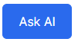  where 37 would be the prediction id | Click on AskAI button | On the right side of the chat screen will appear the message, How coul I improve the ‘your selected property’,  In a few seconds an sense response will be shown on the left side of the chat screen. | 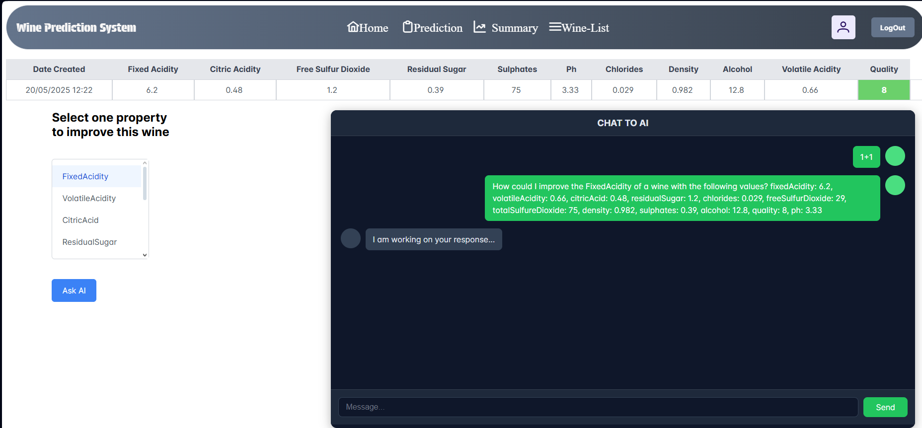

TC022 Chat Ia works once you write any message on input box and press send (Customer ROLE)

Description |  | Chat Ia works once you write any message on input box and press send (Customer Role)
Requirements |  | A user with unless one associate wine.  In case there is not a wine created, execute TC009
Test Data |  | If we do not have customer credentials, Admin will create a new one ( execute TC002 )
Other test elements |  | N/A
Time required | Functional requirement |  | Execution sequence
10 minutes | TC022 |  | Sequential

Cycle 1

Step | Description | Window/Screen | Input data | Output | Observations
1 | We access the system, which must be installed in our environment, and we place ourselves right in the system access window | System access window.  http://localhost:4200/wineList | Customer credentials:  email, password  As we introduce in test case TC002 | Main System window:  Path:  http://localhost:4200/wineList
2 | Go to summary white/idWine | http://localhost:4200/wineList | We press summary button on nav-bar | We will see the http://localhost:4200/summaryWhite/0 with the table of predictions empty
3 | Select wine | http://localhost:4200/whiteWine-page | Press the select wine and select ‘Blanco’ from the list. | Predictions of this wine will be shown on the table.
4 | Navigate to AI screen | http://localhost:4200/summaryWhite/0 | Click on AI button | System will navigate to http://localhost:4200/chat/31 where 31 is winePredictionId.  Screen will look like pic of Observations of this row where prediction row will be shown at the top of the page.
5 | Chat with AI | http://localhost:4200/chat/37  where 37 would be the prediction id | Write an question or a sentence at input at the bottom of the chat-box. | On the right side of the chat screen will appear the message.  In a few seconds an sense response will be shown on the left side of the chat screen.

TC023 Given a wine selected at summary page, charts are shown adn can be filtered (Customer ROLE)
Description |  | Given a wine selected at summary page, charts are shown adn can be filtered (Customer Role)
Requirements |  | A user with unless one associate wine.  In case there is not a wine created, execute TC009
Test Data |  | If we do not have customer credentials, Admin will create a new one ( execute TC002 )
Other test elements |  | N/A
Time required | Functional requirement |  | Execution sequence
10 minutes | TC023 |  | Sequential

Cycle 1

Step | Description | Window/Screen | Input data | Output | Observations
1 | We access the system, which must be installed in our environment, and we place ourselves right in the system access window | System access window.  http://localhost:4200/wineList | Customer credentials:  email, password  As we introduce in test case TC002 | Main System window:  Path:  http://localhost:4200/wineList
2 | Go to summary white/idWine | http://localhost:4200/wineList | We press summary button on nav-bar | We will see the http://localhost:4200/summaryWhite/0 with the table of predictions empty
3 | Select wine | http://localhost:4200/whiteWine-page | Press the select wine and select ‘Blanco’ from the list. | Predictions of this wine will be shown on the table.
4 | View-Chart | http://localhost:4200/summaryWhite/0 | Press the View-chart button next to ‘Select Wine’ button | The screen will be shown as the image aside.  User will be able to filter chart properties by clicking on checkboxes and only property selected will be shown at charts. | 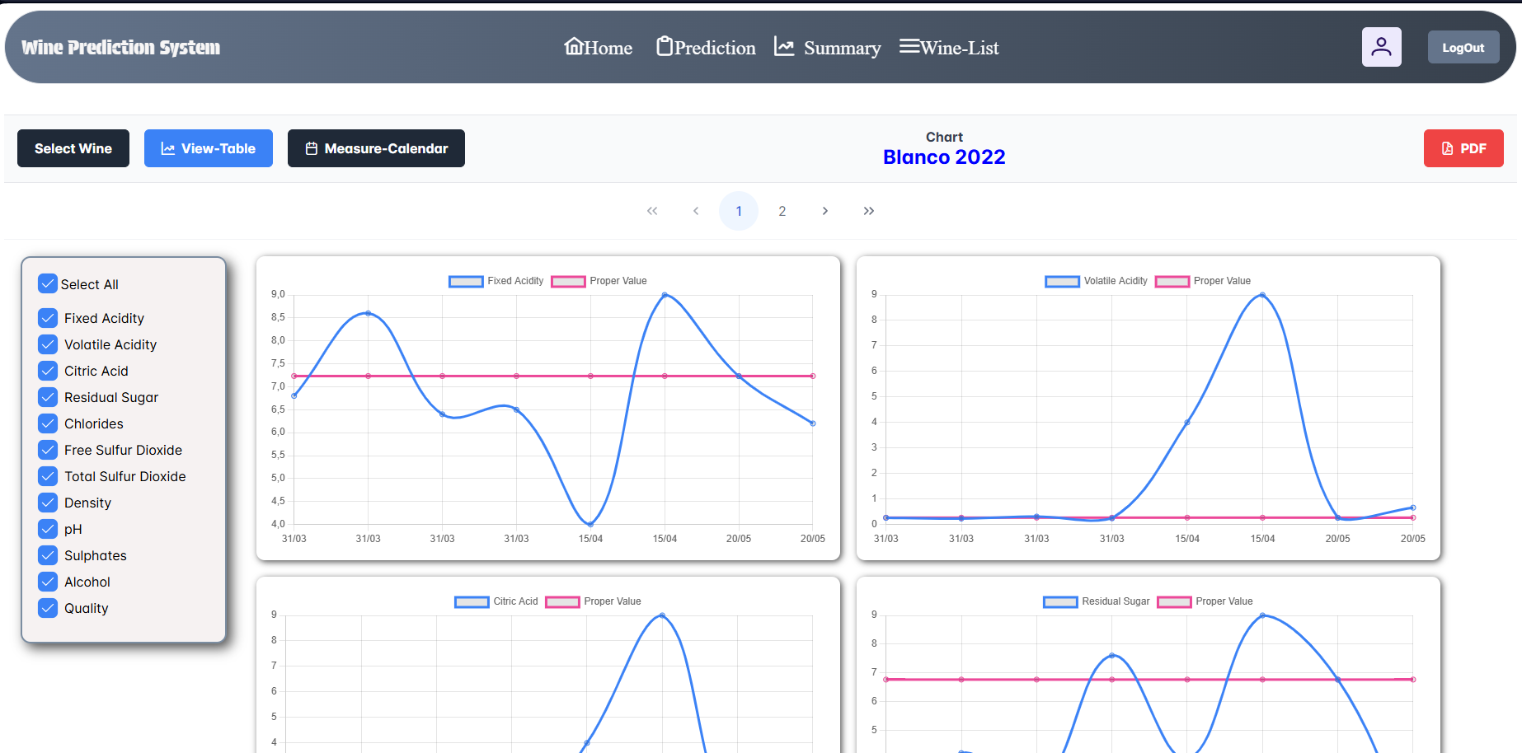

TC024 Given a wine selected, PDF can be downloaded with information of the wine selected and its predictions asociated are also shown(Customer ROLE)
Description |  | Given a wine selected, PDF can be downloaded with information of the wine selected and its predictions asociated are also shown(Customer Role)
Requirements |  | A user with unless one associate wine.  In case there is not a wine created, execute TC009
Test Data |  | If we do not have customer credentials, Admin will create a new one ( execute TC002 )
Other test elements |  | N/A
Time required | Functional requirement |  | Execution sequence
10 minutes | TC024 |  | Sequential

Step | Description | Window/Screen | Input data | Output | Observations
1 | We access the system, which must be installed in our environment, and we place ourselves right in the system access window | System access window.  http://localhost:4200/wineList | Customer credentials:  email, password  As we introduce in test case TC002 | Main System window:  Path:  http://localhost:4200/wineList
2 | Go to summary white/idWine | http://localhost:4200/wineList | We press summary button on nav-bar | We will see the http://localhost:4200/summaryWhite/0 with the table of predictions empty
3 | Select wine | http://localhost:4200/whiteWine-page | Press the select wine and select ‘Blanco’ from the list. | Predictions of this wine will be shown on the table.
4 | Download PDF with wine information | http://localhost:4200/summaryWhite/0 | Press the PDF button on the right side of the site.   | System will download a PDF file with 2 tables:  1st table:  Information of all wines of the username  2nd table:  Information about all wine Predictions of the wine we just selected | 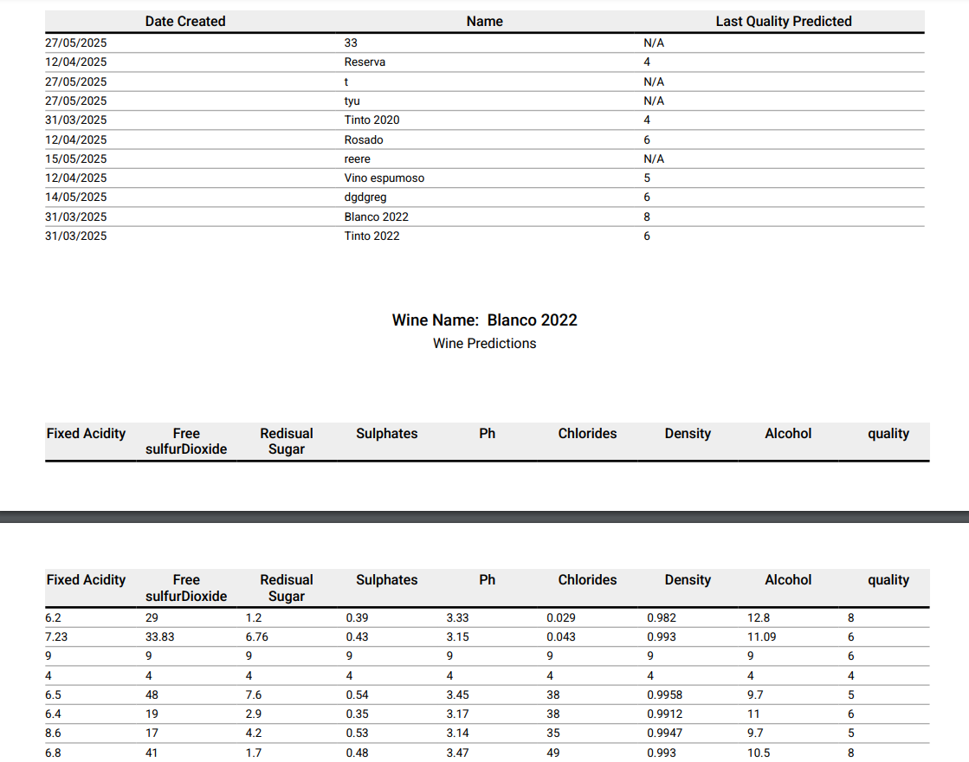

TC025 On the main page button wine prediction navigate to whiteWine-page (Customer ROLE)
Description |  | On the main page button wine prediction navigate to whiteWine-page (Customer Role)
Requirements |  | A user with unless one associate wine.  In case there is not a wine created, execute TC009
Test Data |  | If we do not have customer credentials, Admin will create a new one ( execute TC002 )
Other test elements |  | N/A
Time required | Functional requirement |  | Execution sequence
10 minutes | TC025 |  | Not Sequential

Step | Description | Window/Screen | Input data | Output | Observations
1 | We access the system, which must be installed in our environment, and we place ourselves right in the system access window | System access window.  http://localhost:4200/wineList | Customer credentials:  email, password  As we introduce in test case TC002 | Main System window:  Path:  http://localhost:4200/wineList
2 | We press the home button on the nav-bar side   | http://localhost:4200/main | N/A | http://localhost:4200/main will be shown on the site. | 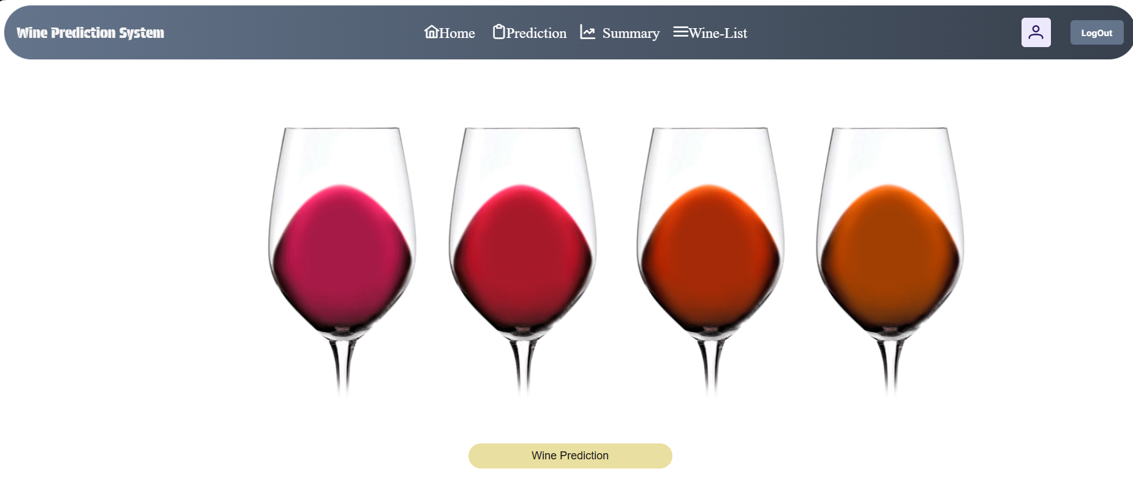
3 | Navigate to Prediction site | http://localhost:4200/main |   Click on Wine Prediction button: | System will navigate to http://localhost:4200/whiteWine-page | 